**Team Members:** Thomas Bock, Ammar Ahmed, Tan Hua, Yan Michael Golez

.

**Group Meeting Minutes:**

* Techniques for getting dimensions from an image (Edge Detection)
* Revision of WBS
* Updating Gantt Chart
* 3-D printed mechanical parts
* Testing Implementation of the Laser
* Functionality of Stepper Motors
* Plans for next week





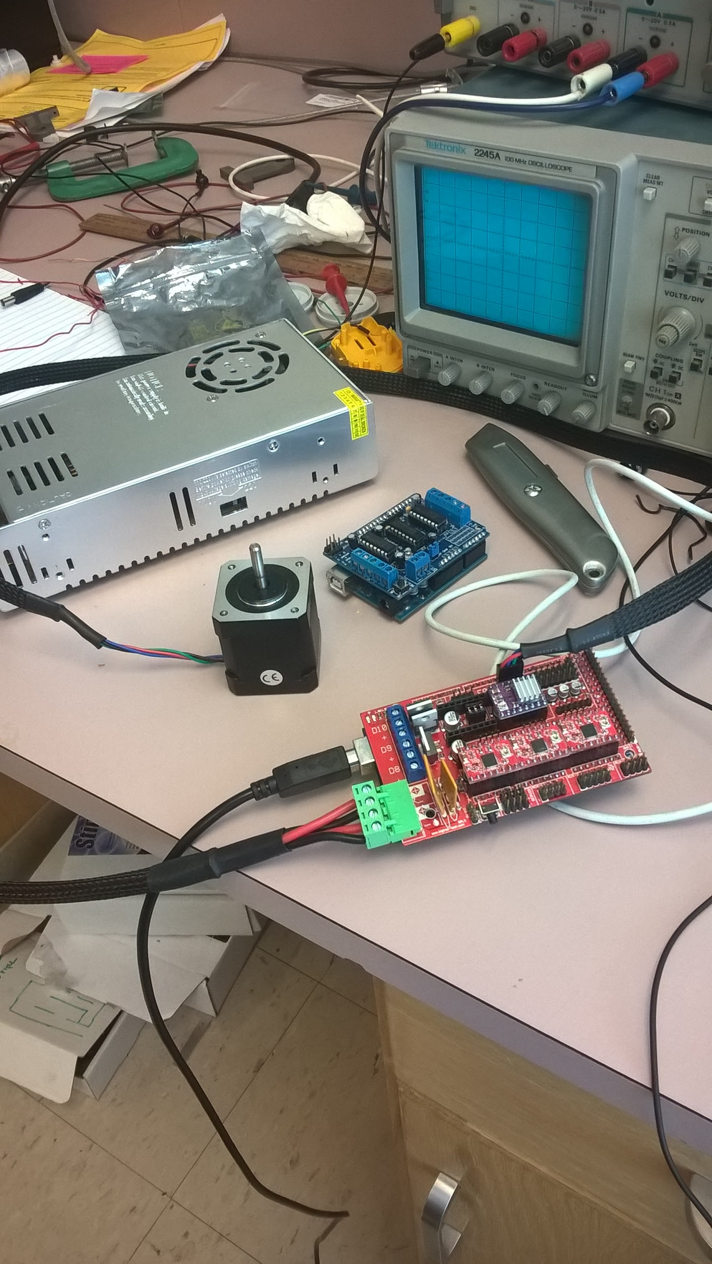

**Summary of Team Tasks Assigned:**

1. Mechanics
   1. Order Panels
   2. 3D Print Parts
   3. Design Mounts for Laser
   4. Cad Model Completed
2. Laser Diode
   1. PWM implementation on the laser driver
   2. Testing of the CNC Laser
3. Software
   1. Arduino testing with motor shield
   2. Matlab and Python communication
   3. G-Code communication with Inkscape
4. Computer Vision
   1. Building a testing workspace for camera calibration
   2. Calibrating the Camera based on the workspace
   3. Exploring and getting comfortable with “Image Processing and Computer Vision” toolbox in Matlab
   4. Write a test code that would take a picture from the camera and put it in Matlab

**Summary of Team Accomplishments:**

1. Mechanics
2. Mounts have been designed
3. 3D printed some parts
4. Full CAD Model finished
5. Laser Diode
6. Prototype Laser Diode was constructed and tested
7. Testing of 445nm 500mW laser diode
8. Implementation of a constant power supply
9. Software
10. Stepper motor was able to move in ZeroPi board
11. G-code file was generated from CAD tool
12. Found supporting programs matching with current hardware
13. Computer Vision
14. The image processing and computer vision toolbox was downloaded and different functions in the library were explored(<https://www.youtube.com/watch?v=lGoYOW2dcJw>)
15. A code was written that would take a picture from the camera and save it on both desktop and workspace on Matlab

**Tasks Assigned for Next reporting period:**

1. Mechanics
   1. Order/Receive Panel
   2. 3-D Print Remaining Parts
   3. Assemble X-Y Platform
   4. Begin testing
2. Laser Diode
   1. PWM implementation on the laser driver
   2. Prototype Laser Diode:Regulate the correct current for functionality
   3. Testing of the CNC Laser
3. Software
   1. Stepper motors manage to move as G-code instructions
   2. Complete software structures with tools and programs
   3. Ensuring the stepper motors working on multiple platforms
4. Computer Vision
   1. Work on the algorithm for edge detection(needed for dimension detection)

**Issues:**

1. Adjustments to the final CAD model changed position of several mounting holes for main panel. Therefore panel still hasn’t been ordered. With final model completed, panel can now be ordered
2. First set of 3D printed parts were undersized and have to be remade. The CAD model did not account for tolerance when 3D printing the parts
3. The compatibility between the ZeroPi board and latest Arduino IDE
4. The testing workspace was not built because the algorithm has to be completed first. It is also necessary to carry a camera on the backpack than carrying the workspace at this stage of the project

**Individual Summary (cont.)**

**Name:** Thomas Bock

**Tasks Assigned for this reporting period:**

1. Order Panel
2. 3D Print Parts
3. Design Mounts for Laser
4. CAD Model Completed

**Accomplishments this reporting period:**

1. Mounts have been designed
2. 3D Printed some parts
3. Full CAD Model finished

**Issues:**

1. Adjustments to the final CAD model changed position of several mounting holes for main panel. Therefore panel still hasn’t been ordered. With final model completed, panel can now be ordered.
2. First set of 3d printed parts were undersized and have to be remade. The CAD model did not account for tolerance changes when 3d printing the parts.

**Tasks Assigned for Next reporting period:**

1. Order/Receive Panel
2. 3D Print Remaining Parts
3. Assemble XY Platform
4. Begin Testing.

**Individual Summary (cont.)**

**Name:** Jan Michael Golez

**Tasks Assigned for this reporting period:**

1. In the fifth week of Design Project, this individual member was assigned to Assemble the laser component.
2. The prototype laser driver circuit was built and tested.
3. Different Power Supply

**Accomplishments this reporting period:**

1. A prototype laser Driver was constructed and tested on the Laser Diode
2. Instead of using a 2W 445nm Blue Diode, a 500mW 445nm blue diode was used for testing purposes.
3. Testing of 500mW Blue Diode: Effective for cutting and engraving

**Issues:**

1. Prototype Laser Driver cannot output current to sustain functionality of Laser Diode.
2. Alteration of resistor values of potentiometer to correct for this problem will be taken care of this week
3. Decision for Power Supply. As of right now group 3 is using a 8pack AA batteries. Efficient, but surely something else must be found
4. Implementation of the PWM module. More research is needed to understand the interaction between the Laser Driver and the microcontroller

**Tasks Assigned for Next reporting period:**

1. PWM implementation on the laser driver
2. Prototype Laser Diode: Regulate the correct current for functionality
3. Testing of the CNC Laser

**Individual Summary (cont.)**

**Name:** Tan Hua

**Tasks Assigned for this reporting period:**

1. Arduino testing with motor shields
2. Matlab and Python communication
3. G-code communication with Inkscape

**Accomplishments this reporting period:**

1. Stepper motor was able to move in ZeroPi board
2. G-code file was generated from CAD tool
3. Found supportive programs matching with current hardware

**Issues:**

1. The compatibility between the zeroPi board and latest Arduino IDE
2. Missing files in library provided from the manufacturer
3. Configuration in Arduino to have stepper motor moving is sophisticated

**Tasks Assigned for Next reporting period:**

1. Stepper motors manage to move as G-code instructions
2. Complete software structure with tools and programs
3. Ensuring the stepper motors working on multiple platforms

**Individual Summary (cont.)**

**Name:** Ammar Ahmed

**Tasks Assigned for this reporting period:**

1. Building a testing workspace for camera calibration
2. Calibrating the camera based on the workspace.
3. Exploring and getting comfortable with “Image Processing and Computer Vision” toolbox in Matlab.
4. Write a test code that would take a pictures from the camera and put it in Matlab workspace.

**Accomplishments this reporting period:**

1. The image processing and computer vision toolbox was downloaded and different functions in the library were explored (<https://www.youtube.com/watch?v=lGoYOW2dcJw>)
2. A code was written that would take a picture from the camera and save it on both desktop and workspace on matlab.

**Issues:**

1. The testing workspace was not built because the algorithm has to be completed first. It is also easier to carry a camera on the backpack than carrying the workspace at this stage of the project.

**Tasks Assigned for Next reporting period:**

1. Work on the algorithm for edge detection (needed for dimension detection)